Marines,

On behalf of Motor Transport Instruction Company, Marine Corps Detachment Fort Leonard Wood, welcome to the Vehicle Recovery Course (VRC). You are receiving this letter because you are registered for VRC. Please ensure you book your flights to arrive on the day of reporting and your return flight no earlier than 1600 on the day of graduation, as it is still a training day. You have been enrolled in MOODLE and it is required to review the material prior to arrival. It is mandatory that you arrive and are seated in the first deck classroom of building 1789 no later than 0600 on the convene date. The Command Screening Checklist can be found [Training Command > Units > Marine Corps Detachment Fort Leonard Wood > MTIC (marines.mil)](https://www.trngcmd.marines.mil/Units/Marine-Corps-Detachment-Fort-Leonard-Wood/MTIC/) under the resources tab.`

**Pertinent Information:**

Report date:

Convene date:

Graduation date:

**Course Prerequisites:**

1. Primary MOS of 3531 or 3537.

2. Be Private to Staff Sergeant.

3. Possess a valid state driver's license.

4. U.S. government vehicle operators' identification card (OF346).

5. Qualified to operate the MTVR 7 ton, MKR18.

6. Proper medical examination card for Motor Vehicle Operators.

7. Air brake endorsement.

8. Must have completed the Drivers Improvement Program (DIP) or Driver Safety Course (CMC) if under the age of 26.

**\*No pre-requisites are waived and will result in dis-enrollment should a Marine not meet the minimum requirement.**

**Billeting/Messing:**

1. Lodging reservations must be made in DTS for government or commercial lodging before reporting. Please ensure that you attempt to stay in hotels located on Fort Leonard Wood. If you cannot get a hotel room on base DTS will generate a non-availability letter for you and then you can proceed to look at hotels out in town. **THE S-1 WILL NOT PROVIDE A LETTER OF NON-AVAILABILTY.**

2. Marines will mess within establishments on or off post. No meal cards will be issued.

**Reporting:**

Students report to S-1, Marine Corps Detachment, Fort Leonard Wood, Missouri, building 1706 during normal working hours (0730-1630). If reporting during non-working hours, report to Command Duty Officer (CDO) at building 1772. **Ensure you have the CDO time/date stamp your orders upon arrival.** No later than **0600 on date to report in**, report to building # 1789 1st deck classroom in **service “A” uniform** located in the specker area.

**Fitreps/JPES:**

Please ensure your TD Fitrep is submitted prior to arrival for all Sergeants. All Corporals and below will have TD JPES occasions completed prior to their arrival due to being TAD for over 30 days.

**Required Items for Check-in: (Marine will be dropped from the course if missing any items)**

1. Copy of your DTS or Reporting orders

2. Command Screening Checklist

3. Of-346, Medical certificate, Driver Improvement Card (If under 26 years old), Military ID, and Driver’s license. All credentials must be valid and can’t expire during the course.

4. Command contact information (SNCO)

5. Name of hotel, room number, phone number of your hotel

6. Copy of return flight

7. Government Charge Card with sufficient credit limit

**MTIC gear will be issued** when the course starts, but you are required or recommended to bring all of the following:

**Gear List**

|  |  |
| --- | --- |
| ITEMS | QUANTITY |
| Green on Green Physical Training Gear (No Logos) Sweat top and bottoms/running suit | 2 Required |
| Glow Belt | 1 Required |
| Running Shoes | 1 Pair Required |
| Glasses | If needed |
| Appropriate hot/cold weather gear | Recommended |
| Woodland Utilities | 2 Sets Required |
| Woodland 8 Point Cover | 1 Required |
| Steal Toe Boots | 1 Pair Required |
| Note Taking Gear | Required |
| Mechanic gloves | Recommended |
| Water Source | Recommended |
| Flak/Kevlar | Recommended |
| Laptop/Tablet | Recommended |
| Safety Glasses | Recommended |

* **Personal Gloves, Personal Laptop/Tablet, Flak/Kevlar, and water source recommended upon reporting to the course. Though it cannot be mandated we cannot stress enough how recommended it is.**

**Points of Contact:**

* VRC Office- (573) 596-1561
* VRC Duty Cell Phone- (573) 337-3041
* MTIC Duty- (573) 596-5729
* Advance Schools Course Chief- (573) 596-5659

If you have any questions or issues prior to check in day; please call one of the numbers listed below:

GySgt Phelps, Joshua C.

Phone Number: (951) 216-4575

Email: Joshua.c.phelps2.mil@army.mil

Vehicle Recovery Course Team Leader

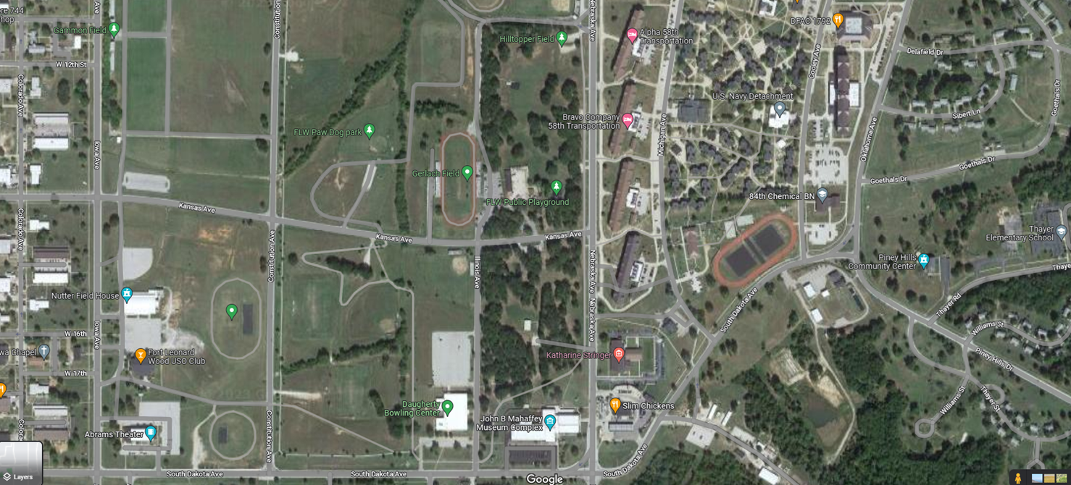

**\*Blue X is building 1789**