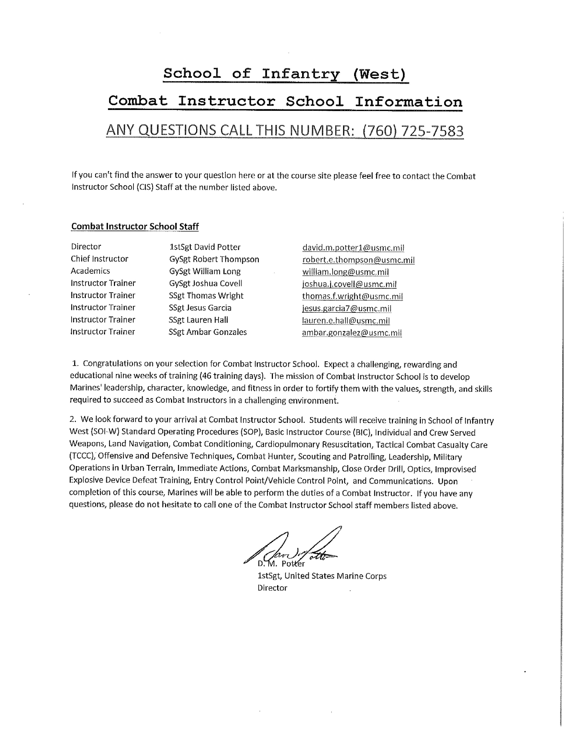
School of Infantry (West)
It is required that you have the following MarineNet courses done before check in:

Course Name Course Code
-USMC Cyber Awareness Training Cyberm0000
Sub course: Personally Identifiable Info DONPII010A
Sub course: Cyber Awareness Challenge DoDCAC1000
-Range Safety RTAMRSOCAA
-Incidental Motor Vehicle Operator HMMWV 35IMVOHV00
Sub course: Intro to the M-Series Vehicle 35IMVOHV10
Sub course: Preventive Maintenance Checks & Services 35IMVOHV20
Sub Course: Operation under Usual Conditions 35IMVOHV30
Sub Course: Operator Maintenance Tasks 35IMVOHV40
Sub course: Operation under Unusual Conditions 35IMVOHV50
-Combating Trafficking in Persons DD01AO0000

Additionally students need to familiarize themselves with MCDP-1, Warfighting.

Directions:
From Interstate-5: If coming from I-5 South, exit at Basilone Road and turn right at the off-ramp. If coming from I-5 North, exit at Basilone Road and turn left at the off-ramp. Follow Basilone Road until you reach the School of Infantry (52 Area).
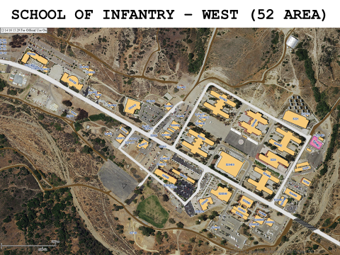
Check in location:
Camp Pendleton, CA. Combat Instructor School office, in Building 520523, Room 120 (Regimental HQ building with the flag pole in front, office door to the left of the main entrance. There will be a sign with instructions outside the door).

Administrative Day 1:
Check in is from 0800 to 1600 on Monday, July 9th, 2018. If you are going to check in late, call and let us know. The uniform is Service “A”. Have plain green on green USMC PT gear available for height/weight verification immediately following administrative in-processing.

Students must check in with:
1. Military ID card
2. Complete set of orders
3. Printed off first page of submitted MROW from last fitness report.
4. Detaching endorsement from parent command
5. Medical and Dental Records
6. Commanding Officer’s Screening Checklist
- The Checklist must be recertified within 30 days of check-in date
7. Motorcycle documentation (if applicable)
8. 36 months of obligated service on contract (30 months if SLDP). Students without the required amount of obligated service time remaining must execute an extension or reenlistment prior to detaching from your parent command. • If EAS is pending, student must bring a copy of submitted RELM 9. Unit Sergeant Major’s name and phone number
10. Camp Pendleton RSO Range ID number (if applicable)
11. Plain green on green USMC PT gear for weigh-in

Student Expenses:
Students will have a few miscellaneous expenses upon arrival to Combat Instructor School. School PT shirts (recommend 2 short-sleeve shirt $8.00/ each, optional sweat shirt and hoodie). Class soda mess is optional, but encouraged as a way for students to offset end-of-course awards, guests gifts and Warriors Night costs. The soda mess is ran and administered by the students.

Uniform of the Day:
Seasonal Utility Uniform

Graduation Requirements:
- Mastery of all performance examinations
- 80% or higher grade on all written examinations
- Completion 20K conditioning hike to time standard
- 1st class score on final PFT during week 9
- 1st class score on final CFT during week 6
- Demonstrate the character that embodies the virtues, core values, and leadership of a Combat Instructor.

Physical Training Preparation:
The physical training program at Combat Instructor School is progressive and challenging. It focuses on total body fitness and includes numerous conditioning hikes and metabolical conditioning. Included in our website training resources 10 and 12 are some helpful resources that will help you to prepare for the rigors of Combat Instructor School. Your command screening checklist recommends that you have a 2nd Class PFT however our POI requires that Marines must score a second class PFT and CFT 30 days prior to class reporting date. As stated above in graduation requirements: Marines must score a first class on the final PFT and CFT in order to qualify for Combat Instructor School Duty.
Safety: Please take precaution when doing any physical exercise. Proper form and safety are extremely important for your health. If you are unfamiliar with an exercise, please see the photos and descriptions for an explanation of proper form.

Organization:
Combat Instructor School is a Special Duty Assignment school under the umbrella of Training and Education Command (TECOM). For personnel and administrative matters, the students are attached to Combat Instructor School, School of Infantry (West), student personnel, MCC J9Y.

Student Chain of Command:
As students, your immediate supervisor is your Instructor Trainer. The Instructor Trainers, Academics Coordinator, Chief Instructor and School Director are available to help you with any concerns. If further assistance is necessary, CIS will direct you to the appropriate service agency.

Administration:
Combat Instructor School will provide you with routine administrative support while you are a student here. Applications for programs offered by the Marine Corps and corrections of errors in records prior to arriving will be deferred until you graduate or return to your parent command. CIS conducts all in/out processing, pay matters, and fitness reports.

Billeting:
Student billeting is located in building 52609. During normal working hours students will check in with Combat Instructor School staff located in building 520523, room 120. Check in will be in Service Alphas. After hours check in will be located in building 520523, with the regimental AOOD/SDNCO. Let them know you are checking into Combat Instructor School and they will provide barracks for you until you check in the following day with Combat Instructor School staff.

Postal:
There is no post office facility in the 52 Area (San Onofre). The nearest one is in Camp Horno, building 53507, telephone (760)725-7547. The mailing address while in attendance at Combat Instructor School is: (STUDENT RANK AND NAME) School of Infantry (West) Combat Instructor School Box 555061 Camp Pendleton, California 92055-5061

Warriors Night:
As part of the program of instruction for Combat Instructor School, students are required to plan and participate in a Warriors Night. The Warriors Night will take place the last week of the course. The cost per person ranges from $35 - $40 (prices are subject to change).

Transportation:
Transportation is limited! There is a bus line that goes throughout the base and goes to Oceanside. It also links with other bus lines. There is a car rental at the Mainside complex, and more are located in Oceanside. Also Uber and Lyft are accessible nearby.

Fitness Reports:
Active Reserve Marines:
You should arrive to Combat Instructor School with a completed “TD” fitness report. Upon completion of the course, you will receive an "FD" fitness report.
Active Duty Marines:
You should arrive to Combat Instructor School with a completed “TR” fitness report. Upon completion of the course, you will receive another "TR" fitness report
These reports will be based on academic achievement, physical fitness, and demonstrated leadership ability. However, all fitness reports will be "Not Observed", with appropriate comments in section "I" (i.e., Top 10%, Honor Graduate, Gung Ho recipient, high physical fitness performer, high shooter).

Class Photo:
Class photos are taken early in the cycle. Purchase is optional. Price is $20.00.

Graduation:
Students graduate in the Service “B” or "C" uniform depending on the season. Uniform of the day or higher is required for military guests. Family and civilian guests are welcome. Command participation is highly encouraged. Graduation locations vary from place to place due to availability, but are typically held in the Advanced Infantry Training Battalion Theatre aboard SOI (W). Please contact CIS for graduation times and locations.

Command Participation:
Commands are encouraged to visit or call the school at any time. We are here to assist.

