UNITED STATES MARINE CORPS
Field Medical Training Battalion
Camp Lejeune

FMSO 1204

M9 Service Pistol Familiarization

TERMINAL LEARNING OBJECTIVES

Given a tactical scenario in a combat environment, an M9 Service Pistol with magazine, individual combat equipment, and ammunition, engage targets with the M9 Service Pistol, to meet mission requirements. (FMSO-FP-1204)

- Given an M9 Service Pistol with magazine, and a small arms maintenance equipment case, maintain the M9 Service Pistol, to meet maintenance requirements. (FMSO-FP-1209)

ENABLING LEARNING OBJECTIVES
- Without the aid of references, given an M9 Service Pistol, a loaded magazine and the necessary equipment at an approved pistol range, fire the M9 Service Pistol without safety violations, per the student handout. (FMSO-FP-1204a)
- Without the aid of references, given a description or title, identify the characteristics of the M9 Service Pistol, per the student handout. (FMSO-FP-1209a)
- Without the aid of references, given a description, identify the parts of the M9 Service Pistol, per student handout. (FMSO-FP-1209b)
- Without the aid of references, given a description, identify the safety features of the M9 Service Pistol, per the student handout. (FMSO-FP-1209c)
- Without the aid of references, given a description or title, identify the weapons conditions of the M9 Service Pistol, per student handout. (FMSO-FP-1209d)
- Without the aid of references, given a description or title, identify the four safety rules for the M9 Service Pistol, per the student handout. (FMSO-FP-1209e)
- DESCRIPTION - The M9, 9mm pistol is a semi-automatic, magazine-fed, recoil-
operated, double-action weapon, chambered for the 9mm cartridge.

- CHARACTERISTICS - The characteristics of the M9, 9mm pistol are as follows:
- Weight with full magazine: 2.54 lbs.
- Weight with empty magazine: 2.12 lbs.
- Magazine capacity: 15 rounds
- Maximum range: 1,800 meters
- Maximum effective range: 50 meters
- Trigger-pull, single action: 4 to 6.5 lbs.
- Trigger-pull, double action: 7.5 to 16.5 lbs.

- THE FOUR SAFETY RULES:
  - Treat every weapon as if it were loaded
  - Never point a weapon at anything you do not intend to shoot
  - Keep your finger straight and off the trigger until you are ready to fire
  - Keep the weapon on safe until you intend to fire

- SAFETY FEATURES (See fig. 1)
- Firing pin block - Physically blocks movement of the firing pin unless the trigger is held to the rear, raising the block out of the way.
- Ambidextrous Safety - Lowers the hammer when applied without the danger of discharging the weapon. Rotates the firing pin striker out of alignment with the firing pin so that no force can be accidentally applied to the firing pin. The hammer cannot be cocked with the safety in the "SAFE" position.
- Half-Cock Notch - Stops the hammer from accidentally falling fully forward should the full-cock notch be stripped. Also catches the hammer should the cocking cycle be interrupted in the double-action fire mode.
- Extractor/Loaded Chamber Iindicator- When a round is in the chamber, the head of the extractor projects out from the surface of the slide, indicating a loaded weapon.

Ambidextrous Slide Safety
Firing Pin Block
Half-cock on the Hammer

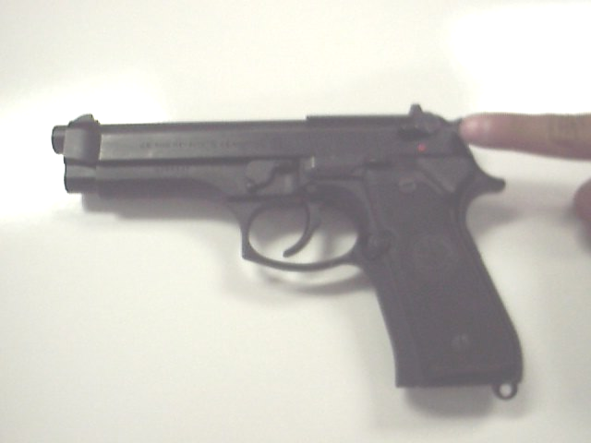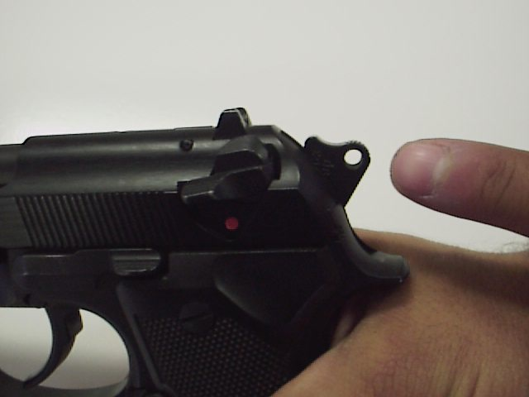
Figure 1. Safety Features

- NOMENCLATURE (See Figure 2)
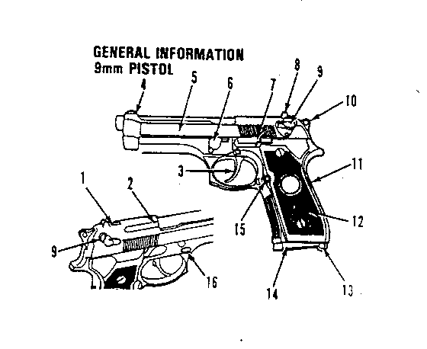
    - Firing pin block
    - Extractor/loaded
Chamber indicator
    - Trigger
    - Front sight
    - Slide assembly
    - Disassembly lever
    - Slide stop
    - Rear sight
    - Ambidextrous safety
    - Hammer
    - Receiver
    - Grip
    - Lanyard loop
    - Magazine (seated)
    - Magazine catch assembly
    - Disassembly button

Figure 2. 9mm

- WEAPON CONDITIONS
Condition Four
    - Magazine Removed
    - Chamber Empty
    - Slide forward
    - Weapon on safe
Condition Three
    - Magazine Inserted
    - Chamber Empty
    - Slide forward
    - Weapon on safe
Condition Two
    - Not Applicable to the M9 Service Pistol
Condition One
    - Magazine Inserted
    - Round in Chamber
    - Slide forward
    - Hammer down
    - Weapon on safe
- DISSASSEMBLY - Disassembly of the M9 service pistol consists of field stripping into the four (4) main groups for operator maintenance. No tools are required, and further disassembly is not authorized for the operator. Parts are machined to close tolerances, and disassembly must be carried out in the prescribed manner to prevent damage to the weapon.
  - The first step in disassembly is to ensure the weapon is clear! Then allow the slide to travel forward by depressing the slide stop.
  - With the pistol in the right hand and the muzzle slightly elevated, use the left hand to depress the disassembly lever release button and rotate the disassembly lever downward until it stops (See fig. 3).

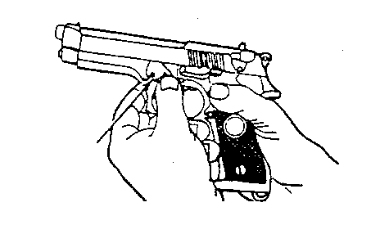

Figure 3. Rotation of Disassembly Lever Release Button

  - Pull the slide and barrel assembly forward and remove (See fig 4)
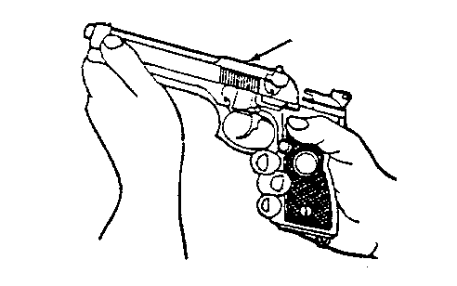

Figure 4. Removal of Slide and Barrel Assembly

  - Compress the recoil spring and spring guide, and lift and remove it from the slide and barrel (See fig. 5)

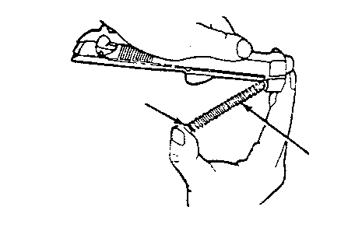

Figure 5. Removal of Recoil Spring from Spring Guide

  - Separate the recoil spring from the spring guide.
  - Push in on the locking block plunger while pushing the barrel forward slightly. Lift and remove the locking/barrel assembly from the slide (See fig. 6)

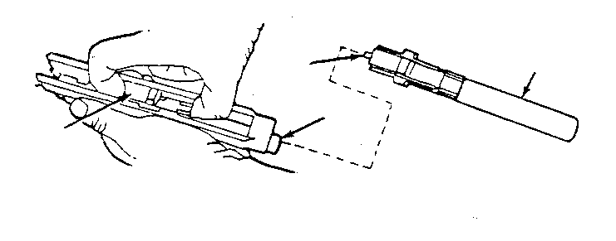

Figure 6. Removal of Locking Barrel Assembly from Slide

  - 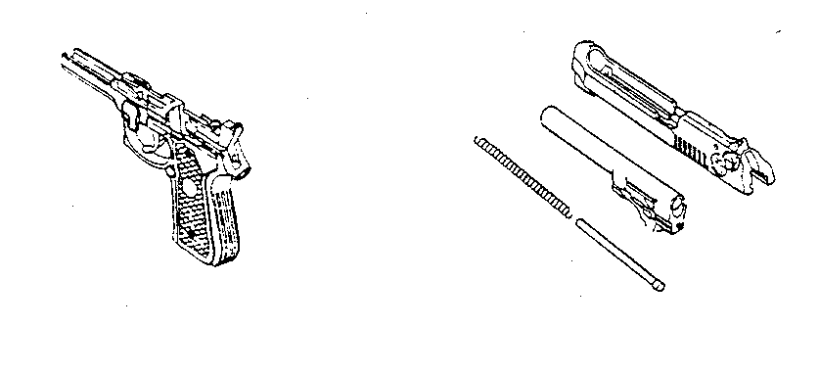This completes general disassembly or fieldstripping. Notice that the weapon is disassembled into four groups. These are the four main groups of the weapon: the (a) locking block/barrel group, (b) the slide group, (c) the recoil spring and spring guide group, and (d) the receiver group. (See fig. 7)
- Figure 7. M9 Main Groups.

- DISASSEMBLY OF THE MAGAZINE (See fig. 8)
  - Unload the magazine
  - Grasp the magazine firmly with the bottom plate up and the back of the magazine tube against the palm of the hand.
  - Release the bottom plate (1) by pushing down on the bottom plate retainer stud (2) in the center of the bottom plate (1). To remove the bottom plate, use the barrel locking block plunger or a cleaning rod. At the same time, slide the bottom plate (1) forward for a short distance using the thumb.
  - While maintaining pressure on the magazine spring, remove the bottom plate (1) from the magazine.
  - Remove the bottom plate retainer, magazine spring (3), and follower (4) from the magazine tube (5). Remove the bottom plate retainer (6) from the magazine spring (3)
  - Inspect – Check the spring and the follower for damage. Ensure that the lips of the magazine are not excessively bent and are free of cracks and burrs. The magazine tube should not be bent or dirty.

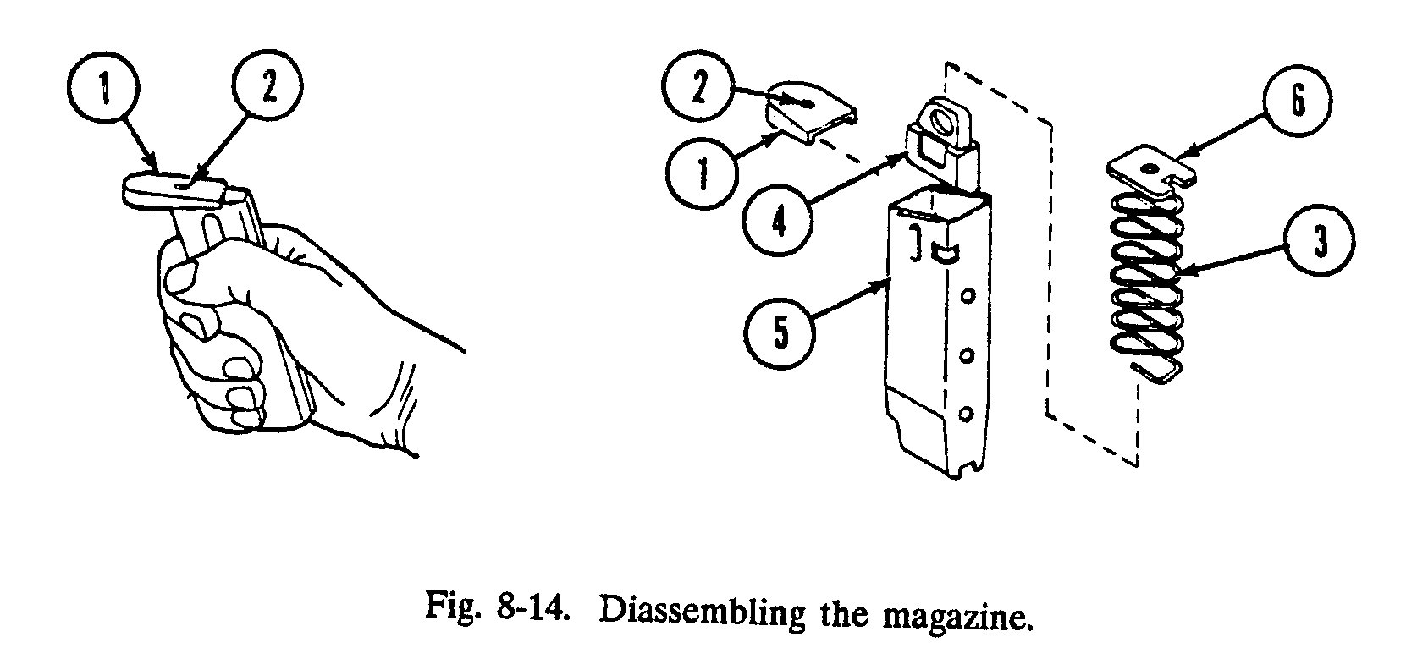
Figure 8. Disassembly of the Magazine

- CLEANING AND INSPECTION - Cleaning will be conducted with the weapon field stripped. The recommended cleaning agent is CLP (Cleaning, lubricate, preservative). During the cleaning process do not allow the hammer to fall when the slide is removed. Always manually lower the hammer when the slide is removed.
- Slide Group - Clean with cloth, the All Purpose (AP) brush, and CLP. Remove all excess dirt and carbon. Ensure the breech face, slide grooves, safety, and extractor are free of dirt and residue.
- Locking block / barrel group - Always clean the barrel from the chamber end first. Use a bore brush to loosen deposits and then swab with a cleaning patch and CLP. Continue this process until a clean patch no longer picks up deposits or residue. Clean the locking block with the AP brush.
- Recoil spring and spring guide - Use the AP brush, cloth, and CLP. Be careful not to stretch, bend, or crimp the spring.
- Receiver group - Use cloth and the AP brush with CLP to clean. Pay special attention to the disassembly lever, trigger, slide stop, hammer, and magazine release button.
- Magazine - Wipe off the magazine tube and the follower with a cloth. Clean the magazine tube and follower with CLP and an All-purpose brush. With a cloth, wipe the magazine spring, bottom plate retainer, and bottom plate clean. Apply a light coat of CLP.
- REASSEMBLY - As with most small arms, reassembly of the M9 is the reverse of disassembly.
  - First, replace the barrel by placing it in the inverted slide, muzzle end first, and then dropping the locking block end into place.
  - Insert the recoil spring guide into the recoil spring. Then replace the assembly in the bottom of the slide by placing the spring into the recoil spring housing and compressing it until the spring guide will fully seat into the locking block cut out.
  - Line up the rear of the slide with the front of the receiver guide rails and push the slide and barrel assembly until the rear of the slide is slightly past the rear of the receiver.
  - Rotate the disassembly latch upward until it clicks in place.

- ASSEMBLY OF THE MAGAZINE (See fig. 9)
  - Insert the follower (1) into the top coil (2) of the magazine spring. The top coil has an upward and forward pointing end. Ensure that the notches (3) on the follower and magazine tube are on the same side.
  - Insert the magazine spring with the follower into the magazine tube. Turn the magazine bottom up with the backside against the palm of your hand.
  - Attach and center the bottom plate of the spring coil.
- After insertion, you must maintain spring tension with your thumb. Do not place the lips of the magazine tube on a hard surface during reassembly
  - Push and hold the magazine spring (5) and the bottom plate retainer (4) down. At the same time, slide the bottom plate (6) over the sidewalls until it is fully seated. This will be indicated by a click.
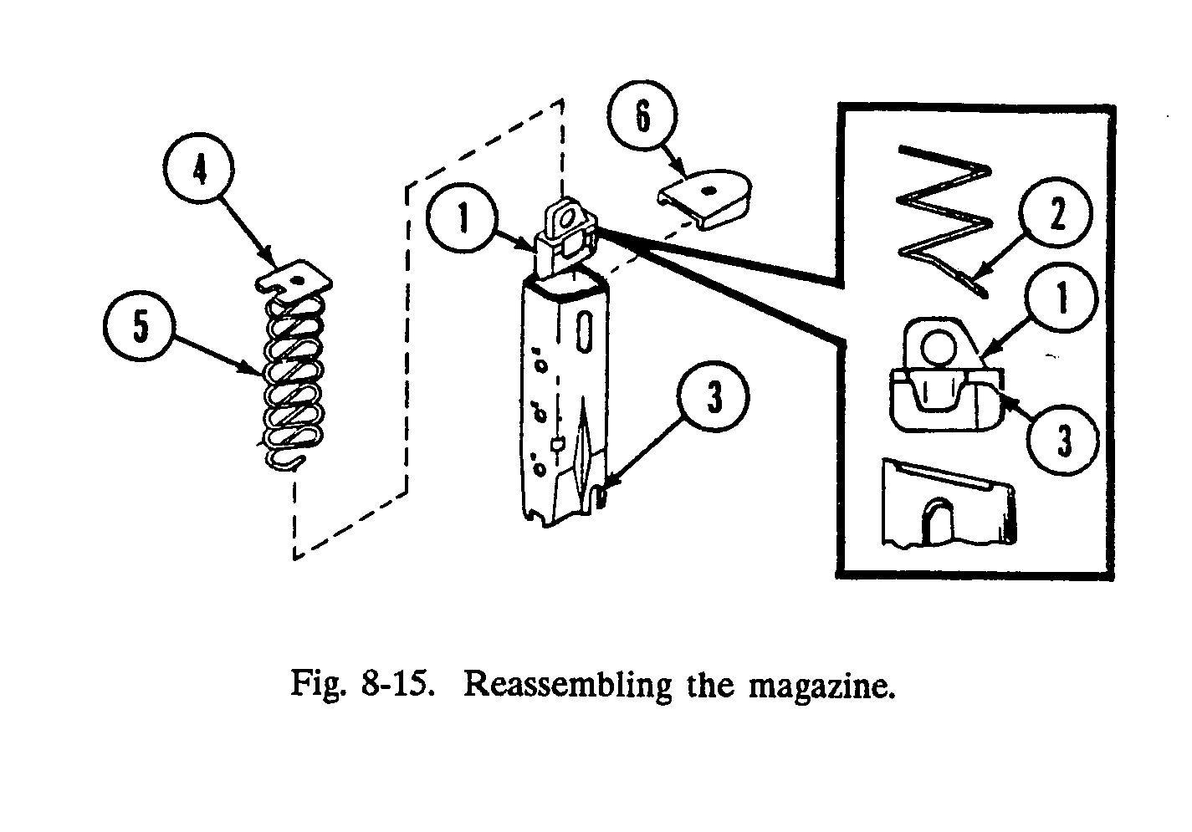
Figure 9. Assembly of the Magazine

- WEAPONS COMMANDS
- Load - Takes the weapon from condition 4 to condition 3.
- Make ready -Takes the weapon from condition 3 to condition 1.
- Fire - Engage target(s).
- Cease-fire - Cease target engagement.
- Unload - Take the weapon from any condition, to condition 4.

REFERENCE
Pistol Marksmanship MCRP 3-01B
Rev: July 2008

