UNITED STATES MARINE CORPS
Field Medical Training Battalion
Camp Lejeune

FMSO 1406

Individual First Aid Kit

TERMINAL LEARNING OBJECTIVE
- Given an injury in an operational environment and an individual first aid kit, utilize Individual First Aid Kit (IFAK) and QuikClot, identify and correctly use the components of the IFAK to minimize/prevent the risk of further injury or death per the references. (FMSO-HSS-1406)

ENABLING LEARNING OBJECTIVE
- Given a simulated casualty, with a completed evaluation of the wound and an individual first aid kit, identify the procedures to treat the wound, to prevent further injury or death, per the student handout. (FMSO-HSS-1406a)
- Given a simulated casualty, with moderate to severe hemorrhage and individual first aid kit, identify the procedures of hemorrhage control using a hemostatic agent, per the student handout. (FMSO-HSS-1604b)

1. COMPONENTS OF THE INDIVIDUAL FIRST AID KIT (IFAK)
The IFAK is designed to be more compact and have greater life saving capability than its predecessors. The IFAK is issued to every Marine and Sailor. The Corpsmen Assault Pack each Corpsman carries will have more medical gear than the IFAK but this section is designed to introduce its contents and characteristics to you.
Bleeding to death is the leading cause of preventable death on the battlefield. As such, each Marine's IFAK contains many of the items discussed in this chapter. It is essential that all Marines are properly trained in their use. Training is one of the many responsibilities of the FMST.
Minor Injury Kit Components:
The minor injury kit is used for minor injuries, cuts, burns and scrapes. The components of the minor injury kit and its use are as follows:
First Aid Ointment - The first aid ointment is the bacitracin antibiotic ointment used to prevent infection on minor cuts, abrasions and scrapes. There are eight contained in the minor injury kit.
Adhesive Bandages - The adhesive bandages are in both large and small sizes. They are used for minor abrasions and cuts. There are 10 small and large adhesive bandages in the minor injury kit.
Triangular Bandage “Non-sterile” - The triangular bandage is a 40”x 40”x 56” material. It is a versatile bandage that comes in a small package with two safety pins. It can be used to hold dressings in place, and as a tie or strap for splinting fractures. There are two triangular bandages in the minor injury kit.
Mini Duct Tape Roll - The mini duct tape is a versatile material that serves multiple purposes. There is one roll of mini duct tape 2”x100” in the minor injury k
Betadine Solution - The betadine solution is in a bottle. It is a disinfectant used to clean and disinfect minor cuts and abrasions. There is one ½ fl.oz bottle of betadine solution in the minor injury kit.
Burn Dressing “Water Jel” - The burn dressing is a 4” x 16” woven material saturated with a gel. It is FDA approved and has been proven to extinguish white phosphorous burns. It is the first response for burn injuries. When applied to a burn, it cools the burn area, reduces the chance for hypothermia, and prevents the burn from further progression. It protects the burn from further contamination, infection and eases the pain of the burn victim.
Water Purification Tablets - The water purification tablets purify water of questionable potability. It is contained in a bottle and used to purify up to 1 quart of water.
Trauma Kit Components:
The trauma kit is used for major bleeding injuries to include life-threatening bleeding. The components of the trauma kit and its use are as follows.
Bulky Gauze Rolls - There are two cotton gauze rolls in the trauma kit. The gauze rolls are used for the protection of minor wounds and loosely wrapped around the burn dressing to secure it over the burn area. They can also be used to apply direct pressure to medium and severe bleeding from wounds and used to wipe away excess blood prior to the application of a hemostatic agent.
Pressure Dressing - There are two pressure-dressing bandages in the trauma kit. These pressure dressing bandages are 4” wide elastic wraps with 8” x 10” absorbent cotton pad attached close to the end of one side of the elastic wrap. On the other side of the absorbent pad, in the middle on the elastic wrap side is a hard plastic H-anchor that allows for application by an individual. At both ends of the elastic wraps are Velcro strips that allow and at one end of the elastic wrap is a plastic hooks on each side to further reinforce pressure dressing is secure. Pressure dressings can be applied to chest, abdominal, head, neck, and extremity wounds.
- METHODS OF HEMORRHAGE CONTROL
Tourniquets: (for more information see the PHTLS, 6th Ed, pages 501-513).
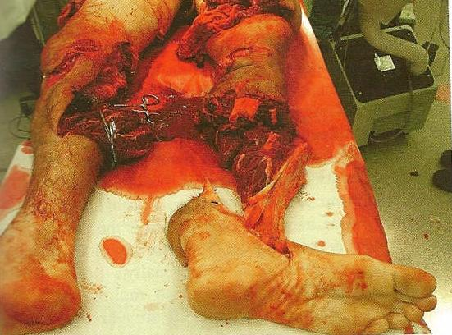
In civilian trauma care the use of a tourniquet is reserved for when direct pressure fails, this is not the case in Care Under Fire. The initial treatment for an extremity hemorrhage in a tactical setting is a tourniquet. A pressure dressing can be used later in the care process of a combat casualty.
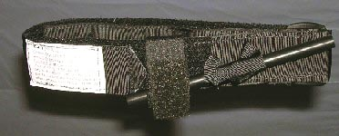
The standard “web belt through the buckle” tourniquet issued by the military during Vietnam was not highly regarded by the combat medic community. The U.S. Army Institute of Surgical Research identified the Combat Application Tourniquet (CAT) as the one best suited for battlefield use. This tourniquet can be rapidly applied with one hand to one’s own or another’s extremities. This tourniquet is issued throughout all U.S. combatant forces. If the CAT tourniquet is not available the provider should be able to make a “field expedient” tourniquet. The use of the tourniquet in a combat setting is not limited to solely the CAT, there may be other brands of tourniquets. While it may have a different name, the principles of use are similar. The goal is to stop arterial bleeding in an extremity to prevent loss of life. Imagine trying to control the bleeding of the casualty in figure 1 without a tourniquet!
Figure 1. Casualty who was saved using a tourniquet
Characteristics of the CAT (see figure 2):
- Tourniquet of choice
- Lightweight
- Easy to apply and use
Field Expedient Tourniquet (see fig 3)
- If CAT is unavailable, choose a material about two inches (2”) wide.
Figure 2. CAT Tourniquet
- Material such as rope, wire, and string should NOT be used because they can cut into flesh.

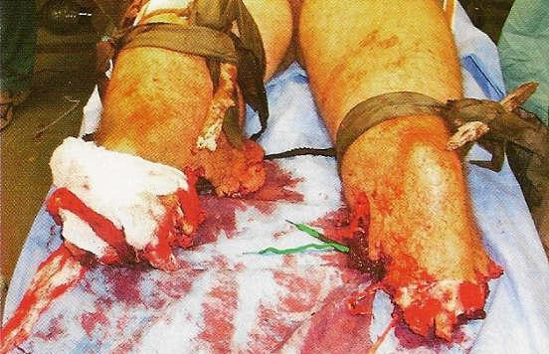
- Tie a strong windlass (stick) to a cravat or other strong material.
- Slide one or two rings on each side of the cravat.
- Tie the cravat around the affected limb, two to four inches above the wound, loosely. (This will allow the windlass to turn, creating circumferential pressure to stop the bleed.)
- Twist the windlass until the hemorrhage is controlled.
Figure 3. Improvised Tourniquets
- Slide the ring to the windlass and secure windlass to the ring(s).
Tourniquet Application
Application Site - a tourniquet should be applied just above the hemorrhaging wound. Do not place a tourniquet below the knee or elbow or over a joint. If you place a tourniquet below the knee or elbow, there are two bones, i.e., Tibia/Fibula below the knee and Radius/Ulna below the elbow, which can splint the hemorrhaging vessel and make it impossible to control the bleed.
Application Ttightness - apply tourniquet tight enough to block arterial flow. Generally, the bigger the limb, the tighter the tourniquet. So a leg will require more pressure to control bleeding than an arm will.
What about those Rings???
Examples of good rings to use:
- Key chain rings
- Sport drink rings
- Boot laces tied into a ring
- Anything that is in a ring shape with the approximate diameter of 1-2 inches
Other Considerations - a tourniquet will be painful for the conscious casualty to tolerate but don’t stop tightening until the hemorrhage is controlled. Pain management should be considered, provided that the casualty does not have signs of Class III or IV shock. You must document placement of a tourniquet by placing a “T” and the time of application on the casualty’s forehead. After application, do not cover a tourniquet under any condition, leave it exposed for easy monitoring for continued hemorrhage.
Converting A Tourniquet To A Dressing
Whenever a tourniquet has been required, consider transitioning to another mode of hemorrhage control during the Tactical Field Care phase. In order to properly convert a tourniquet, you must:
- Apply pressure dressing.
- Leave tourniquet in place and slowly loosen.
- Monitor for bleeding from underneath the dressings.
- If bleeding is not controlled, retighten tourniquet and remove pressure dressing.
- Apply HemCon, per the instructions.
- Apply pressure dressing over HemCon.
- Leave tourniquet in place and slowly loosen.
- Monitor for bleeding from underneath the dressings.
- If bleeding is not controlled, retighten tourniquet and remove dressings.
- Apply QuikClot, per the instructions.
- Leave tourniquet in place and slowly loosen.
- Monitor for bleeding from underneath the dressings.
- If bleeding is not controlled, retighten tourniquet and expedite CASEVAC.
Converting a tourniquet back to a dressing should NOT be attempted when:
- The casualty is in Class III or IV shock
- There has been a complete amputation
- There is no one to observe casualty for rebleeding
- Tourniquet in place for more than 6 hours

- HEMOSTATIC AGENTS (QuikClot and HemCon, see figures 4 & 5)
These products will cause the wound to develop a clot that will stop the flow of blood and will remain within the wound until removed by medical personnel. They are applied to wounds with moderate to severe bleeding (venous or arterial). Both hemostatic agents have unique properties and both have strengths and liabilities and carry with them the requirement for specific training for all members of the combat team. There is no singular, best method to control hemorrhage. Each situation is different. Factors such as the amount of blood lost, proximity to surgical care, number of other casualties and resources available (medical and transport) will affect the decision.
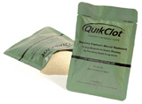
QuikClot: A mineral that is highly effective in controlling hemorrhaging. It is granular, packaged in an individual airtight package, and can be poured into a wound after pooled blood has been removed. It looks and feels like coarse sand. This product is effective in stopping bleeding, but it can have undesirable side effects because of the heat generated when it gets wet. The heat is caused by the exothermic reaction that occurs when QuikClot absorbs water from the wound, thereby concentrating the clotting factors in the blood. This heat generated can be enough to cause burns. This product has been used safely in the civilian trauma setting and by the military during Operation Iraqi Freedom. Although the data regarding QuikClot is not plentiful or standardized, to date the reports have shown that lives were saved when it was used properly.
Figure 4. QuikClot
- In the presence of normal (undiluted) blood, this adsorption causes only a slight body temperature increase (approximately 109-114° F. If blood is extremely diluted, exothermic reaction can be more extreme.
- In the presence of liquids like WATER, more extreme heat can be generated by this adsorption. This reaction lasts approximately 4-5 seconds and then ENDS. Once granules have adsorbed all the liquid possible, they go INERT.
- Exothermia (production of heat) is controlled by adjusting the balance between volume of water and volume of product.
- Flooding the granules with water can instantly stop the exothermic reaction and adsorption.
Application Procedures (for more information see the PHTLS, 6th Ed. pages 533-534 or visit the LRC on the Command Quarterdeck to watch a video of it being used on a pig)
- Apply direct, firm pressure to wound.
- If bleeding is stopped or nearly stopped after one minute of pressure, wrap and tie bandage to maintain pressure on wound and CASEVAC, as no further immediate treatment is needed.
- If moderate to severe bleeding continues after 90 seconds, hold QuikClot away from face and tear open at tabs.
- Remove previously applied bandages, making certain to wipe away as much excess blood and liquid as possible.
- Pour (DO NOT DUMP) QuikClot in a back-and-forth motion onto the source of bleeding. QuikClot changes from its dry light beige color to a dark color as it adsorbs moisture and begins to clot.
- Stop pouring promptly when you see a dry layer of QuikClot on wound indicating that there is no more blood to adsorb.
- Immediately bandage wound and apply firm direct pressure.
- CASEVAC patient as soon as possible to a medical facility.
- Be certain QuikClot package accompanies patient so receiving medical staff can follow directions to remove QuikClot properly.
Precautions
QuikClot should NOT be used on the following wounds:
- Chest Trauma, to include sucking chest wounds
- Head, neck, and face injuries
- Spurting blood - The caregiver should be aware that continuously spurting blood from a small diameter puncture wound could create a high-pressure exit path. The source of such bleeding may be too far away from the entry point for QuikClot to be effective.
- Slow the bleed with a tourniquet for extremity hemorrhage or pressure points for non-extremity hemorrhage, and then apply QuikClot in conjunction with a pressure dressing. SLOWLY release the tourniquet or pressure point. Reassess effectiveness.
- Do not ingest or inhale QuikClot.
- If ingested, drink several glasses of water and seek medical attention.
- Keep away from the face when opening or pouring.
- If inhaled, move to open air or a well-ventilated space.
- Do not use bare hands to apply pressure immediately following application of QuikClot.
- If adsorbing granules cause heat discomfort to skin, promptly brush away and/or flood with water.
- Sterility not guaranteed if package is damaged or opened. Safely discard damaged open packages.
- Keep away from children
NOTE: If you cannot see where the hemorrhage is coming from, DO NOT USE QuikClot. It must be poured on the hemorrhaging vessel to be effective.

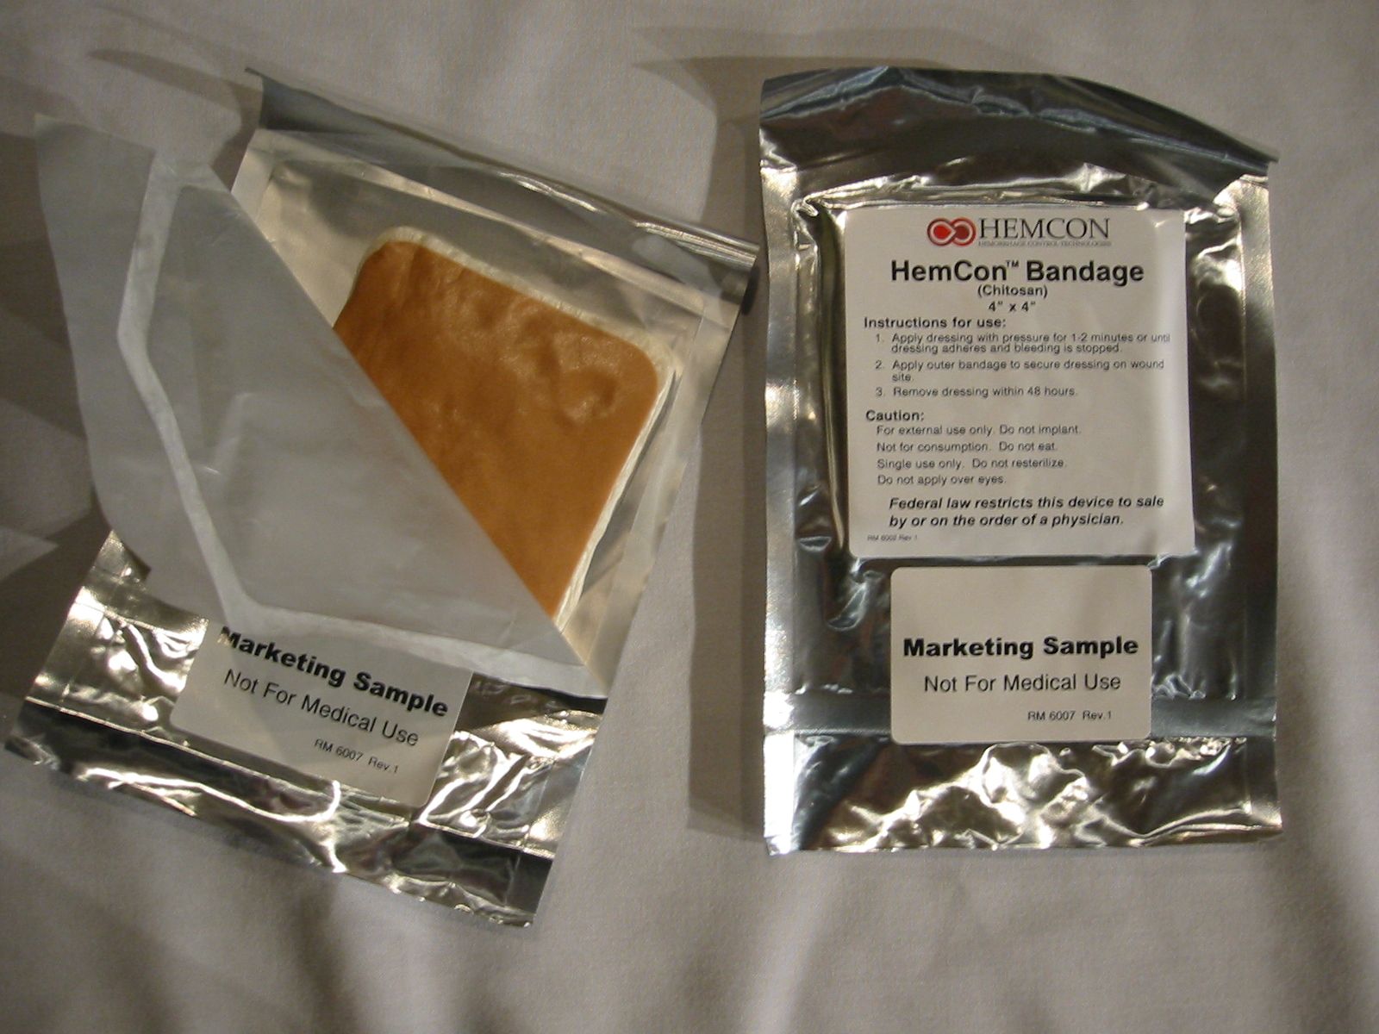
HemCon - This product is made from shrimp shells but does NOT cause reactions in persons allergic to shellfish or iodine. The Chitosan (Kahy-tuh-san) side of the dressing promotes hemostasis by forming a strong durable clot to moderate and severe external hemorrhage. It also seals the injury site to further bleeding and external infectious agents.
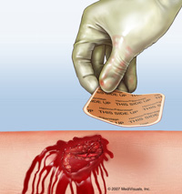
Application Procedures (see figure 6 or for more information see PHTLS, 6th Ed. pages 511-513)
Figure 5. HemCon dressing
- Open the bandage, grasping the opposing edges of the foil pouch and pull apart.
- Ensure that the non-stick side is up. HemCon bandages have two sides: a cream-colored active side, which goes on the wound, and a darker non-stick side which is labeled “THIS SIDE UP.” The bandage will not work upside down.
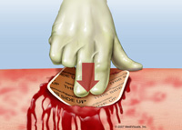
- Apply directly on source of bleeding. It is critical to place the bandage on the source of the bleeding, the area where the blood vessel damage has actually occurred. For smaller wounds, the bandage can be cut to smaller pieces. For larger wounds, multiple bandages can be used.
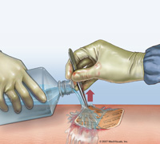
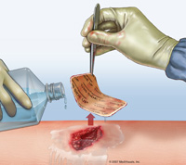
- Apply firm, even pressure to the side labeled “THIS SIDE UP.” Backing the bandage with a gauze roll helps ensure uniform pressure and increases performance. Maintain pressure on the bandage for at least two minutes or until bleeding is controlled. If bandage is not effective after four minutes, remove original and apply a new bandage. Additional bandages may NOT be applied over ineffective bandages. HemCon should be covered with a pressure dressing once shown to be effective. The bandage can remain in place for up to 48 hours and should be removed with water or saline.

NOTE: Once applied and in contact with blood or other fluids, you have less than 30 seconds to adjust or reposition the bandage. Apply a new bandage to other exposed bleeding sites.
Figure 6. HemCon Application

REFERENCES:

User’s Instruction for the Individual First Aid Kit (IFAK)
MCRP 3-02G First Aid

Rev: Jan 2008

