Contacting SOI-E  - While on leave report any of the following issues to the SOI-E ITB or MCT Staff Duty Officer (SDO) as soon as it is feasible:  - Delays in your travel (due to unforeseen events)  - Legal issues involving civilian law enforcement/authorities  - Medical issues involving hospitalization  - COVID signs and symptoms while en route to SOI-E  - SDO Contact Information  - ITB SDO: (910) 449-0235  - MCT SDO: (910) 449-0390  - Your first call is ALWAYS to the ITB or MCT SDO  - If unable to reach the SDO for either ITB or MCT, call the following in sequential order until your call is received:  - Administrative Student Center:  - (910) 449-2032 (Mon-Fri: 0730-1600)  - SOI-E Officer of the Day:  - (910) 449-0179 (Office)  - (910) 376-5485 (Duty Cellphone)  COVID-19 Mitigation Measures  - While on leave wear a face covering when required and practice social distancing. You will be required to wear a black face covering or mask and practice social distancing when reporting to SOI-E and during training.  - If a family member/friend will be dropping you off on your report date to SOI-E it is your responsibility that they abide by COVID mitigation measures at all times. See link below for current face covering policy.  - COVID-19 Camp Geiger Face Covering Policy:  - https://www.mcieast.marines.mil/News/Article/Article/2712420/new-covid-19-face-covering-policy/  School of Infantry-East  School of Infantry-East  PSC Box 20161  Camp Lejeune, NC 28542-0161 |  |  | Entry-Level Student  Reporting Procedures  School of Infantry-east  - Camp Geiger, North Carolina

3 Updated: 16 Nov 2021
Arriving to School of Infantry-East (SOI-E)  - SOI-E is located aboard Camp Geiger in Jacksonville, NC. Camp Geiger is co-located with Marine Corps Air Station New River and both share the same front gate.  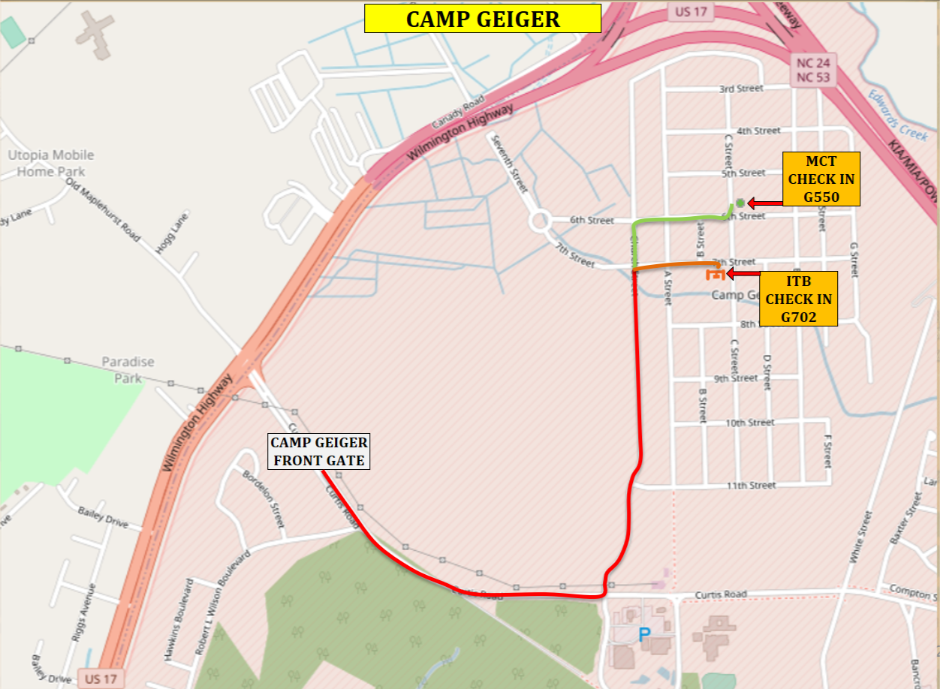  6th St.  7th St.  Church St.  Curtis St.  - Arriving By Plane  - You will be flying into the ALBERT J. ELLIS (OAJ) airport located in Jacksonville, NC, which is about 16 miles north of Camp Geiger.  - Arriving By Bus  - You will arrive at 2434 ONSLOW DR., JACKSONVILLE, NC 28540  - Taxis are available at the airport and bus station. Taxi fare is approximately $20-30 from the bus station and $35-$40 from the airport. Keep your taxi fare receipt so you can be reimbursed. Book a taxi from the “Approved Taxi List” on the SOI-E website.  - Arriving by Privately Owned Vehicle (POV)  - YOU ARE NOT ALLOWED to obtain/or utilize a POV at any time during your travel to SOI-E. A family member may drop you off at your check-in location. Students are not authorized to use POVs while undergoing training. |  |  | Reporting in to SOI-E  - Report to SOI-E immediately upon arriving to Jacksonville or the surrounding area. You are strongly advised not to book a hotel as you will not be reimbursed for this expense.  - Travel in civilian attire only.  - You are required to report in to SOI-E in your Service “A” uniform and with a fresh haircut. (You will be provided an area to change into your uniform at your report in location.)  - Infantry Training Battalion (ITB)  - ITB students check in at BUILDING G702 no later than the date and time designated on your original orders.  - Marine Combat Training Battalion (MCT)  - MCT students check in at BUILDING G550 no later than the date and time designated on your original orders.  - It is strongly advised to check in to your respective battalion during normal working hours (0730-1600) to ensure you have ample time to be adequately supplied with information and gear.  What to bring with you  ***Bring all items and uniforms you were issued in boot camp in the same issued baggage!!!***  - Pack the following items in your carry on:  - Service Record Book (SRB) with original orders  - Military identification card  - COVID-19 vaccination card  - Dental Record  - Medical Record  - Cash or debit card ($200 Minimum)  - Issued military glasses with ballistic inserts (if applicable)  - 1 pair of boots  - 1 set of woodland utilities  - 1 set of skivvies  - Hygiene gear
1 2

