MCRD-COMM-1001 HAND AND ARM SIGNALS

TERMINAL LEARNING OBJECTIVE

- Given a command or situation while wearing an assault load, communicate using hand and arm signals by performing 16 out of 40 signals correctly. (MCRD-COMM-1001)

ENABLING LEARNING OBJECTIVES

- Without the aid of references and given a diagram and a list of choices, identify the hand-and-arm signal for “forward” in accordance with MCWP 3-11.2. (MCRD-COMM-1001a)

- Given a command or situation, while wearing an assault load, execute the hand-and-arm signal for "forward" in accordance with MCWP 3-11.2. (MCRD-COMM-1001b)

- Without the aid of references and given a diagram and a list of choices, identify the hand-and-arm signal for “change direction (right or left)” in accordance with MCWP 3-11.2. (MCRD-COMM-1001c)

- Given a command or situation, while wearing an assault load, execute the hand-and-arm signal for "change direction (right or left)” in accordance with MCWP 3-11.2. (MCRD-COMM-1001d)

- Without the aid of references and given a diagram and a list of choices, identify the hand-and-arm signal for “enemy in sight” in accordance with MCWP 3-11.2. (MCRD-COMM-1001e)

- Given a command or situation, while wearing an assault load, execute the hand-and-arm signal for "enemy in sight" in accordance with MCWP 3-11.2. (MCRD-COMM-1001f)

- Without the aid of references and given a diagram and a list of choices, identify the hand-and-arm signal for “assemble” in accordance with MCWP 3-11.2. (MCRD-COMM-1001g)

- Given a command or situation, while wearing an assault load, execute the hand-and-arm signal for "assemble" in accordance with MCWP 3-11.2. (MCRD-COMM-1001h)

- Without the aid of references and given a diagram and a list of choices, identify the hand-and-arm signal for “fire team” in accordance with MCWP 3-11.2. (MCRD-COMM-1001i)

- Given a command or situation, while wearing an assault load, execute the hand-and-arm signal for "fire team" in accordance with MCWP 3-11.2. (MCRD-COMM-1001j)

- Without the aid of references and given a diagram and a list of choices, identify the hand-and-arm signal for “form column” in accordance with MCWP 3-11.2. (MCRD-COMM-1001k)

- Given a command or situation, while wearing an assault load, execute the hand-and-arm signal for "form column" in accordance with MCWP 3-11.2. (MCRD-COMM-1001l)

- Without the aid of references and given a diagram and a list of choices, identify the hand-and-arm signals for “skirmishers left/right” in accordance with MCWP 3-11.2. (MCRD-COMM-1001m)

- Given a command or situation, while wearing an assault load, execute the hand-and-arm signals for "skirmishers left/right" in accordance with MCWP 3-11.2. (MCRD-COMM-1001n)

- Without the aid of references and given a diagram and a list of choices, identify the hand-and-arm signals for “echelon left/right” in accordance with MCWP 3-11.2. (MCRD-COMM-1001o)

- Given a command or situation, while wearing an assault load, execute the hand-and-arm signals for "echelon left/right" in accordance with MCWP 3-11.2. (MCRD-COMM-1001p)

- Without the aid of references and given a diagram and a list of choices, identify the hand-and-arm signal for “wedge” in accordance with MCWP 3-11.2. (MCRD-COMM-1001q)

- Given a command or situation, while wearing an assault load, execute the hand-and-arm signal for "wedge" in accordance with MCWP 3-11.2. (MCRD-COMM-1001r)

- Without the aid of references and given a diagram and a list of choices, identify the hand-and-arm signal for “freeze” in accordance with MCWP 3-11.2. (MCRD-COMM-1001s)

- Given a command or situation, while wearing an assault load, execute the hand-and-arm signal for "freeze" in accordance with MCWP 3-11.2. (MCRD-COMM-1001t)

- Without the aid of references and given a diagram and a list of choices, identify the hand-and-arm signal for “increase speed” in accordance with MCWP 3-11.2. (MCRD-COMM-1001u)

- Given a command or situation, while wearing an assault load, execute the hand-and-arm signal for "increase speed" in accordance with MCWP 3-11.2. (MCRD-COMM-1001v)

- Without the aid of references and given a diagram and a list of choices, identify the hand-and-arm signal for “decrease speed” in accordance with MCWP 3-11.2. (MCRD-COMM-1001w)

- Given a command or situation, while wearing an assault load, execute the hand-and-arm signal for "decrease speed" in accordance with MCWP 3-11.2. (MCRD-COMM-1001x)

- Without the aid of references and given a diagram and a list of choices, identify the hand-and-arm signal for “close up” in accordance with MCWP 3-11.2. (MCRD-COMM-1001y)

- Given a command or situation, while wearing an assault load, execute the hand-and-arm signal for "close up" in accordance with MCWP 3-11.2. (MCRD-COMM-1001z)

- Without the aid of references and given a diagram and a list of choices, identify the hand-and-arm signal for “open up, extend” in accordance with MCWP 3-11.2. (MCRD-COMM-1001aa)

- Given a command or situation, while wearing an assault load, execute the hand-and-arm signal for "open up, extend" in accordance with MCWP 3-11.2. (MCRD-COMM-1001ab)

- Without the aid of references and given a diagram and a list of choices, identify the hand-and-arm signal for “shift” in accordance with MCWP 3-11.2. (MCRD-COMM-1001ac)

- Given a command or situation, while wearing an assault load, execute the hand-and-arm signal for "shift" in accordance with MCWP 3-11.2. (MCRD-COMM-1001ad)

- Without the aid of references and given a diagram and a list of choices, identify the hand-and-arm signal for “halt” in accordance with MCWP 3-11.2. (MCRD-COMM-1001ae)

- Given a command or situation, while wearing an assault load, execute the hand-and-arm signal for "halt" in accordance with MCWP 3-11.2. (MCRD-COMM-1001af)
- SIGNALS. Signals are used to transmit commands or information when voice communications are difficult, impossible, or when silence must be maintained. Subordinate leaders repeat signals to their units whenever necessary to ensure prompt and correct execution.

- Whistle. Whistle is an excellent signal device for the small unit leader. It provides a fast means of transmitting a message to a large group. However, unless the signal is prearranged and understood, it may be misinterpreted, and there are always the dangers that whistle signals from adjacent units may cause confusion. Battlefield noises will reduce the whistle's effectiveness.

- Special. Special signals consist of all special methods and devices used to transmit commands or information. The squad leader, operating at night, may use taps on his helmet or rifle butt to signal halt, danger, move forward, or assemble here. These signals must be understood and rehearsed prior to their use. Various pyrotechnics and smoke signals may be used as signals to attack, withdraw, mark front lines, indicate targets, and cease or shift fire. Before leaders devise others, they should check with their platoon commander to make sure that they are not using a signal, which already has a set meaning.

- Hand-and-Arm Signals. Hand and Arm signals are a type of visual signal that marines use to communicate with each other over short distances when verbal communication is impossible or silence must be maintained.

- Decrease Speed. Extend the arm horizontally sideward, palm to the front and wave the arm downward several times, keeping the arm straight. Arm does not move above the horizontal.

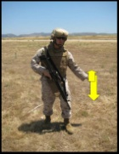

- Change Direction. Raise the hand that is on the side toward the new direction across the body, palm to the front; then swing the arm in a horizontal arc, extending arm and hand to point in the new direction.
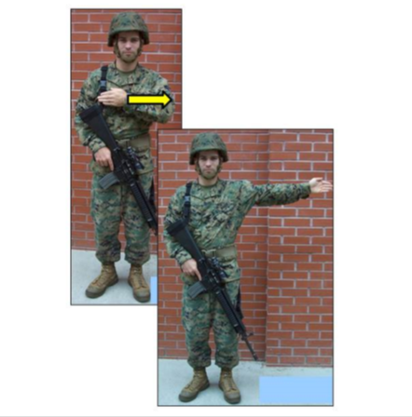

- Enemy in Sight. Hold the rifle horizontally, with the stock in the shoulder, muzzle pointing in the direction of the enemy. Aim in on the enemy target and be ready to engage him if he detects your presence.
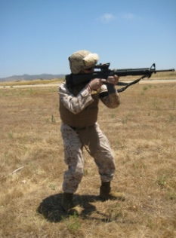

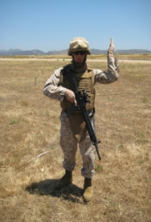
- Assemble. Raise the hand vertically to the full extent of the arm, fingers extended and joined, palm to the front, and wave in large horizontal circles with the arm and hand.

- Form Column. Raise either arm to the vertical position. Drop the arm to the rear, describing complete circles in a vertical plane parallel to the body. The signal may be used to indicate either a troop or vehicular column.

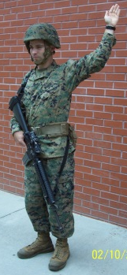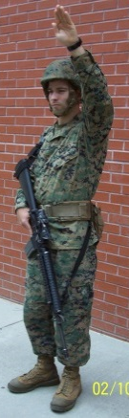

- Shift. Point to individuals or units concerned, beat on chest simultaneously with both fists, and then point to location you desire them to move to.

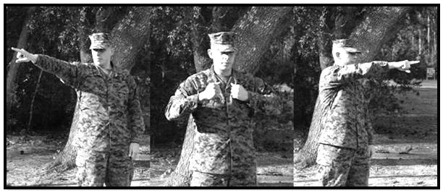

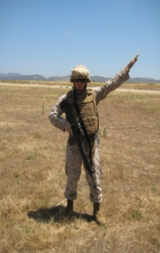
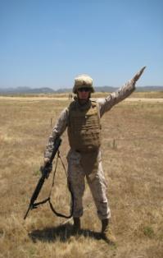
- Echelon Left or Right. The leader may give this signal either facing towards or away from the unit. Extend one arm 45 degrees below the horizontal, palms to the front. The lower arm indicates the direction of echelon.
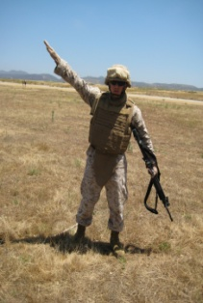
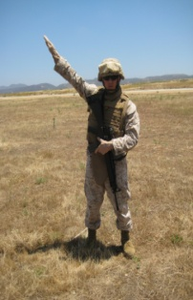

Left Right

- Skirmishers (Fire Team). Raise both arms lateral until horizontal, arms and hands extended palms down. When signaling for fire team skirmishers, indicate skirmishers right or left by moving the appropriate hand up and down. Moving the left hand up and down will always indicate skirmishers left; skirmishers right, the right hand.
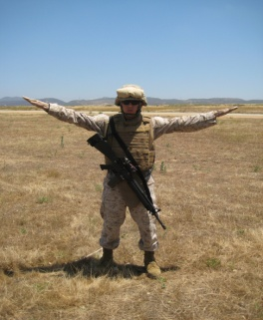

- Wedge. Extend both arms downward and to the side at an angle of 45 degrees below the horizontal, palms to the front.
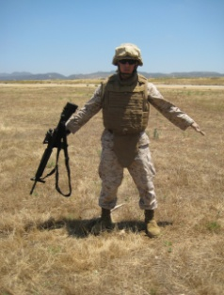

- Hasty Ambush Right (Left). Raise fist to shoulder level and thrust it several times in the desired direction.
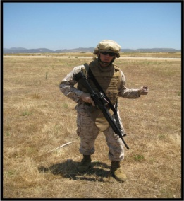

- Fire Team. The right arm should be placed diagonally across the chest.
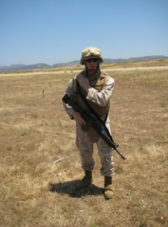

- Close Up. Start signal with both arms extended to the side, palms forward, and bring palms together in front of the body momentarily. When repetition of this signal is necessary, the arms are returned to the starting position by movement along the front of the body.
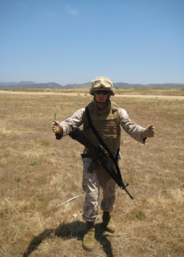

- Open Up, Extend. Start signal with arms extended in front of the body, palms together, and bring arms to the horizontal position at the sides, palms forward. When repetition of this signal is necessary, the arms are returned along the front of the body to the starting position and the signal is repeated until understood.
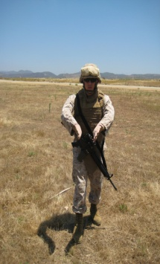

- Forward, Advance. Face and move in the desired direction of march; at the same time extend the arm horizontally to the rear; then swing if overhead and forward in the direction of movement until it is horizontal, palm down.
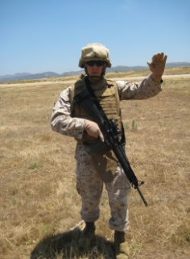

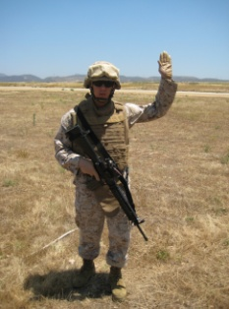
- Halt. Carry the hand to the shoulder, palm to the front; then thrust the hand upward vertically to the full extent of the arm and hold it in that position until the signal is understood.

- Freeze. Make the signal for Halt and make a fist with the hand.
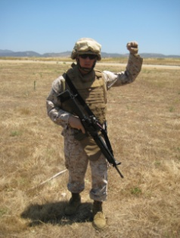

- Increase Speed, Double Time. Carry the hand to the shoulder, fist closed; rapidly thrust the fist upward vertically to the full extent of the arm and back to the shoulder several times. This signal is also used to increase gait or speed.

NOTES:_______________________________________________________________________________________________________________________________________________________________________________________________________________________________________________________________________________________________________________________________________________________________________________________________________________________________________________________________________________________________________________________________________________________________________________________________________________________________________________________________________________________________________________________________________________________________________________________________________________________________________________________________________________________________________________________________________ ____________________________________________________________________________________________________________________________________________________________________________________________________________________________________________________________________________________________________________________________________________________________________________________________________________________________________________________________________________________________________________________________________________________________________________________________________________________________________________________________________________________________________________________________

